|  |
| --- |
| SLNG |
| Stream 5: GL, CC, PC and WBS Workflow Creation in K2 System |
|  |

|  |
| --- |
| KPMG Services Pte. Ltd.  Jan 2024 |
| This report contains pages |
| Appendices comprise 3 pages |
|  |

© 2023 KPMG Services Pte. Ltd. (Registration No: 200003956G), a Singapore incorporated company and a member firm of the KPMG global organization of independent member firms affiliated with KPMG International Limited, a private English company limited by guarantee. All rights reserved.

**Document classification: KPMG Confidential**

Document review and approval

Revision history

|  |  |  |  |
| --- | --- | --- | --- |
| Version | Author | Date | Revision |
| V1 | KPMG Singapore | 26 Sep | Create Document |
|  |  |  |  |
|  |  |  |  |
|  |  |  |  |
|  |  |  |  |

This document has been reviewed by

|  |  |  |
| --- | --- | --- |
|  | Reviewer | Date reviewed |
|  | Abhishek Dubey | 28 Sep 2023 |
|  |  |  |
|  |  |  |
|  |  |  |
|  |  |  |

This document has been approved by

|  |  |  |  |
| --- | --- | --- | --- |
|  | Subject matter experts | |  |
|  | Name | Signature | Date reviewed |
|  | Deven Chhaya |  | 28 Sep 2023 |
|  |  |  |  |
|  |  |  |  |
|  |  |  |  |
|  |  |  |  |

Contents

1 Background of K2 Workflow Improvement 3

2 GL/CC/PC Master Data Maintenance Approval Workflow. 3

3 WBS Master Data Maintenance Approval Workflow. 6

4 New request GL Creations. 10

5 Appendix A: Data fields Description: 20

6 Environments 32

# Background of K2 Workflow Improvement

Presently, SLNG seeks to uphold an approval workflow for modifying, generating, and activating data within the K2 platform (Version: 5.0007.1000.1) to facilitate process automation throughout various departments. SLNG is committed to introducing new IT processes, including:

1. GL/CC/PC Master Data Maintenance Approval Workflow.
2. WBS Master Data Maintenance Approval Workflow.

The technical details of each process are explained in the following sections.

# GL/CC/PC Master Data Maintenance Approval Workflow.

Within the financial domain, SLNG is dedicated to ensuring the meticulous maintenance and effective management of master data.

The workflow below illustrates the whole process from the request submission to the end of the implementation.

Start

**Requester**

Revise Request

**Requester**

Resubmit

Submits Request

Revise

**Reporting Manager**

Evaluates Request

Revise / Cancel

Request

Cancel

End

**Requester**

Evaluates Request

Send Back

Reject

End

Approve /

Reject /

Send Back

Approve

**Implementer**

Enters Implementation details and Close Request.

Submit

Send Back

Send Back

Reject

Reject

End

End

Approve /

Reject /

Send Back

**BPO**

Evaluates Request

Submit /

Reject /

Send Back

**Implementer**

Assesses Request

Approve

End

| No. | Process | Proposed Features in the Process |
| --- | --- | --- |
|  | Raise Request. | * The system allows requesters to submit the request. |
|  | Evaluate Request | * The system allows the Reporting Manager to view and evaluate the Request. The Reporting manager can approve, reject, or send back. |
|  | Approves Request | * If the configuration submitted can be accepted, the Reporting Manager can approve the submission. |
|  | Rejects Request | * If the configuration submitted isn’t required and can’t be accepted, the Reporting Manager can reject the submission. |
|  | Send Back with Comments | * If the configuration submitted is required and can’t be accepted, the system allows the Reporting Manager to send the submission back with comments to revise the detailed configuration. |
|  | Revise configuration details | * The system allows the Requester to view and evaluate the Request. The Requester can Revise and resubmit or cancel the request. |
|  | Assess Request | * The system allows the Implementer to view and evaluate the Request. The Implementer can submit, reject, or send back. |
|  | Reject Request | * If the configuration submitted isn’t required and can’t be accepted, the Implementer can reject the submission. |
|  | Send Back with Comments | * If the configuration submitted is required and can’t be accepted, the system allows the Implementer to send the submission back with comments to revise the detailed configuration. |
|  | Revise configuration details | * The system allows the Requester to view and evaluate the Request. The Requester can Revise and resubmit or cancel the request. |
|  | BPO Evaluate Request | * The system allows the Business Process Owner (BPO) to view and evaluate the Request. The BPO can approve, reject, or send back. |
|  | Rejects Request | * If the configuration submitted isn’t required and can’t be accepted, the BPO can reject the submission. |
|  | Send Back with Comments | * If the configuration submitted is required and can’t be accepted, the system allows the BPO to send the submission back with comments to revise the detailed configuration. |
|  | Approves Request | * If the configuration submitted can be accepted, the BPO can approve the submission. |
|  | Revise configuration details | * The system allows the Requester to view and evaluate the Request. The Requester can Revise and resubmit or cancel the request. |
|  | Implements approved configurations. | * The Implementer implements approved configurations. |

# WBS Master Data Maintenance Approval Workflow.

The workflow below illustrates the whole process from the request submission to the end of the implementation.

Start

**Requester**

Revise Request

**Requester**

Resubmit

Submits Request

Revise

**Reporting Manager**

Evaluates Request

Revise / Cancel

Request

Cancel

End

Send Back

Reject

End

Approve /

Reject /

Send Back

**Requester**

Evaluates Request

Approve

Reject

End

Implement/

Reject /

Send Back

**Implementer**

Assesses Request

Send Back

**Implementer**

Enters Implementation details andRequest.

End

Implement

Proposed features in the process are mapped in the table below:

| No. | Process | Proposed Features in the Process |
| --- | --- | --- |
|  | Raise Request. | * The system allows requesters to submit the request. |
|  | Evaluate Request | * The system allows the Reporting Manager to view and evaluate the Request. The Reporting manager can approve, reject, or send back. |
|  | Approves Request | * If the configuration submitted can be accepted, the Reporting Manager can approve the submission. |
|  | Rejects Request | * If the configuration submitted isn’t required and can’t be accepted, the Reporting Manager can reject the submission. |
|  | Send Back with Comments | * If the configuration submitted is required and can’t be accepted, the system allows the Reporting Manager to send the submission back with comments to revise the detailed configuration. |
|  | Revise configuration details | * The system allows the Requester to view and evaluate the Request. The Requester can Revise and resubmit or cancel the request. |
|  | Assess Request | * The system allows the Implementer to view and evaluate the Request. The Implementer can Implement, reject, or send back. |
|  | Reject Request | * If the configuration submitted isn’t required and can’t be accepted, the Implementer can reject the submission. |
|  | Send Back with Comments | * If the configuration submitted is required and can’t be accepted, the system allows the Implementer to send the submission back with comments to revise the detailed configuration. |
|  | Revise configuration details | * The system allows the Requester to view and evaluate the Request. The Requester can Revise and resubmit or cancel the request. |
|  | Implements approved configurations. | * The Implementer implements approved configurations. |

# New request GL Creations.

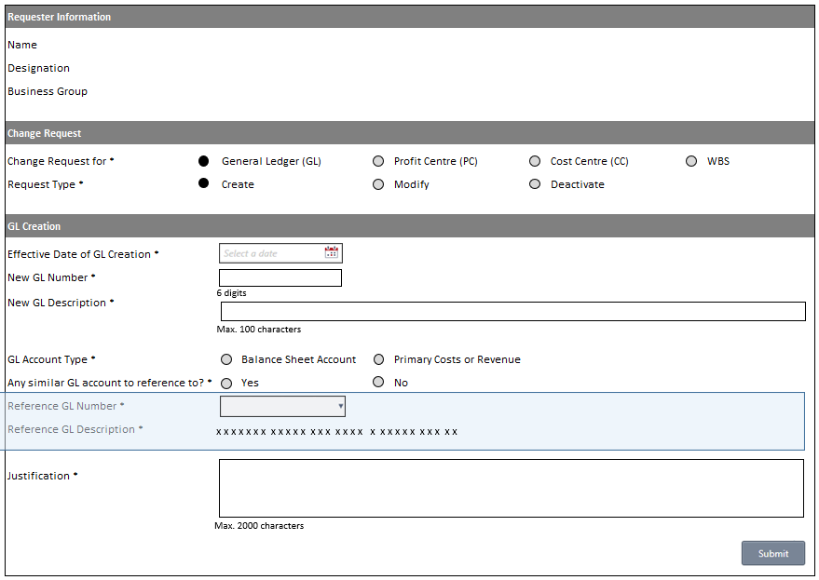

Figure 1: Screenshot of New request GL Creations.

* Users will login to the system using their credentials.
* The details such as Name, Designation, and Business group will be automatically populated based on the login ID.
* User is allowed to choose an option in the "Change request for" field and select one option from the "Request type page."
* The user must choose a date from the "Effective Date of GL Creation" field, ensuring that the date is not earlier than today.
* Users can input the New GL Number and New GL Description.
* The user must select the GL Account type, and if "Any similar GL account is a reference to? - Yes" is chosen, the corresponding section will be displayed, with "Reference GL Number" becoming mandatory.
* Choosing a "Reference GL Number" will auto-populate the "Reference GL Description."
* Users are required to justify the designated box before submitting the form by selecting the “Submit” button. The form will then be routed to the reporting manager. An email will be sent to the Reporting Manager.

**New request GL Modification:**

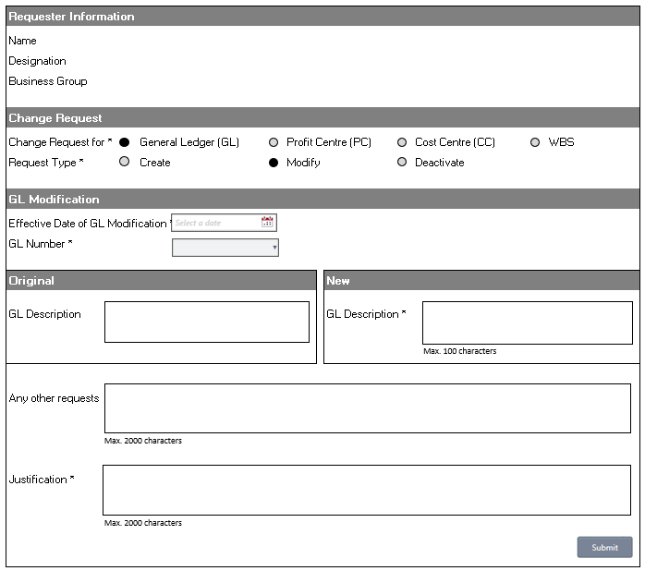

Figure 2 Screenshot of New request GL Modification.

* Users will log in to the system using their credentials.
* The details such as Name, Designation, and Business group will be automatically populated based on the login ID.
* The user is allowed to choose an option in the "Change request for" field and select one option from the "Request type."
* The user must choose a date from the "Effective Date of GL Creation" field, ensuring that the date is not earlier than today.
* Choosing "GL Number" automatically populates the original "GL Description," which is non-editable.
* Users have the option to modify the GL description in the designated new "GL description" text box. Additionally, they can input any other requests in the text box.
* Before submitting the GL Modification form, users are required to justify the modifications made in the designated "Justification" text box.
* Submission of the form is completed by clicking on the "Submit" button. The form will then be routed to the reporting manager. An email will be sent to the Reporting Manager.

**New request GL Deactivation:**

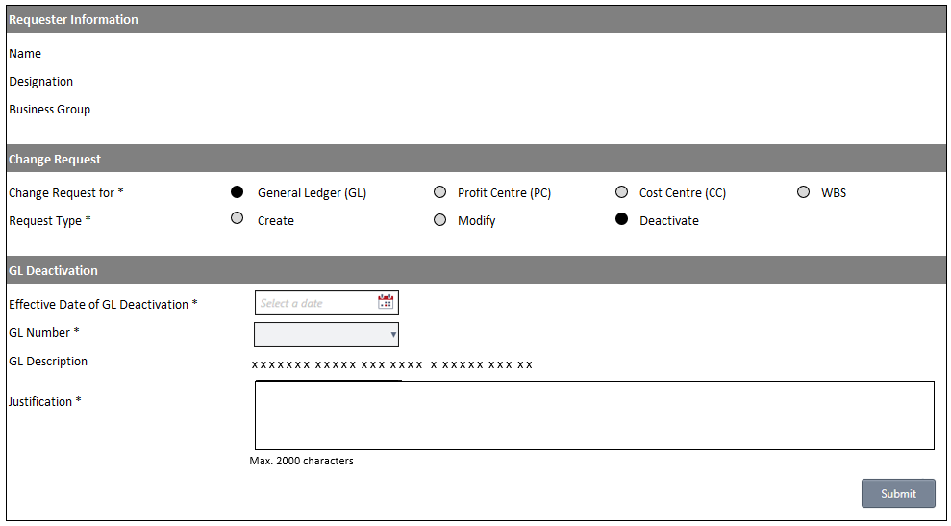

Figure 3 Screenshot of New request GL Deactivation

* Users will log in to the system using their credentials.
* The details such as Name, Designation, and Business group will be automatically populated based on the login ID.
* The user is allowed to choose an option in the "Change request for" field and select one option from the "Request type."
* The user must choose a date from the "Effective Date of GL Creation" field, ensuring that the date is not earlier than today.
* Choosing "GL Number" automatically populates the original "GL Description," which is non-editable.
* Users can deactivate the GL by selecting the “Deactivate” option in the Request type field.
* Before submitting the GL Deactivation form, users are required to justify the changes made in the designated "Justification" text box.
* Submission of the form is completed by clicking on the "Submit" button. The form will then be routed to the reporting manager. An email will be sent to the Reporting Manager.

**Reporting Manager approval:**

Figure 4: Screenshot of Reporting Manager approval

* Upon submission of the request form, the form will be redirected to the Reporting Manager approval page. On this page, the user is granted read-only access to review the details submitted by the requester.
* The request date is automatically populated with the date on which the requester submitted the form. Simultaneously, the MDM number is generated automatically upon the requester's submission, and the status is indicated as “Pending Reporting Manager Approval.”
* The approver, or Reporting Manager, can evaluate the form and take necessary actions such as "Approve," "Reject," or "Send Back." In the event of choosing "Reject" or "Send Back," the approver is required to provide reasons in the comments box.
* If the Approver or Reporting Manager opts for the "Send back" option, the form will be redirected to the requester for revision. The form will then be routed to the requester. An email will be sent to the requester. The form will then be routed to the reporting manager.

**Requester Rework:**

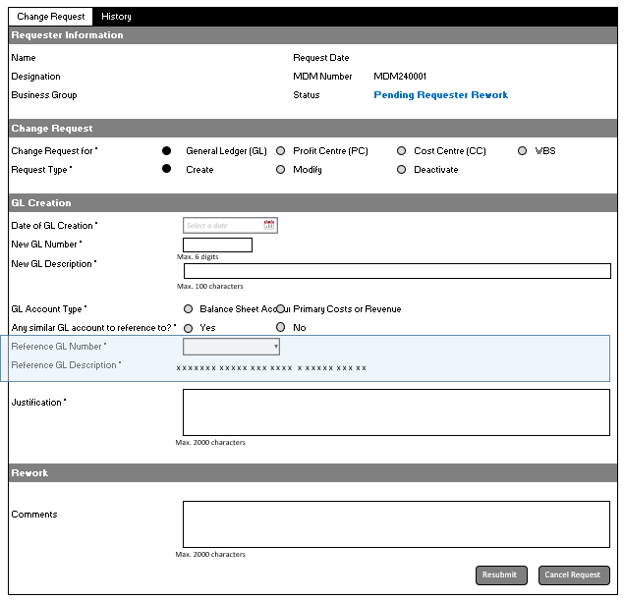

Figure 5 Screenshot of Requester Rework

* Upon redirection to the requester, the form status will be labelled as "Pending Requester Rework." The form's data is pre-populated, and users are granted access to make necessary changes.
* The requester, guided by the approver's comments, will implement the required modifications and subsequently resubmit the form along with additional comments in the designated comments box.

**Implementer Assessment:**

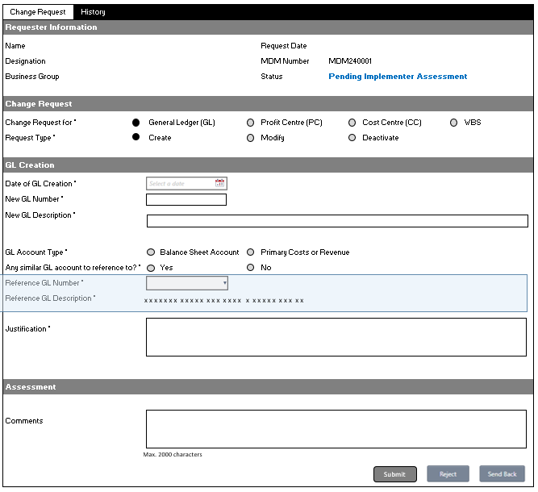

Figure 6 Screenshot of Implementer Assessment

* Following the Approval Manager's approval of the requester's submission, the form is redirected to the implementer. The form's status will be marked as "Pending Implementer Assessment."
* In this form, showcasing information on Creation/Modification/Deactivation submitted by the requester, all fields are presented in an uneditable format. The implementer has view-only access, enabling actions such as "Submit," "Reject," or "Send back" based on the information provided.
* If the implementer chooses to Reject or Send back the form, comments become mandatory to provide reasons for the decision.

**BPO Approval:**

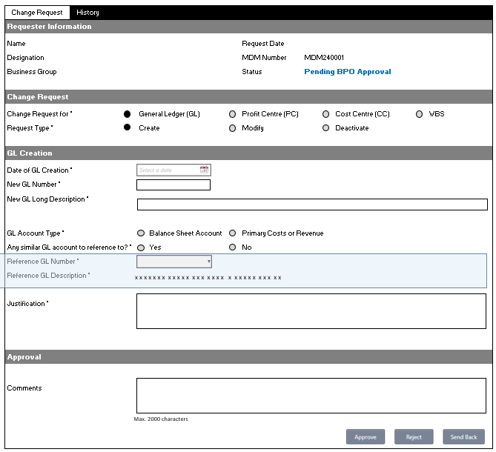

Figure 7 Screenshot of BPO Approval

* Following the Implementer’s approval of the requester's submission, the form is redirected to the BPO. The form's status will be marked as "Pending BPO Approval."
* In this form, showcasing information on Creation/Modification/Deactivation submitted by the requester, all fields are presented in an uneditable format. The BPO has view-only access, enabling actions such as "Approve," "Reject," or "Send back" based on the information provided.
* If the BPO chooses to Reject or Send back the form, comments become mandatory to provide reasons for the decision.

**Implementation:**

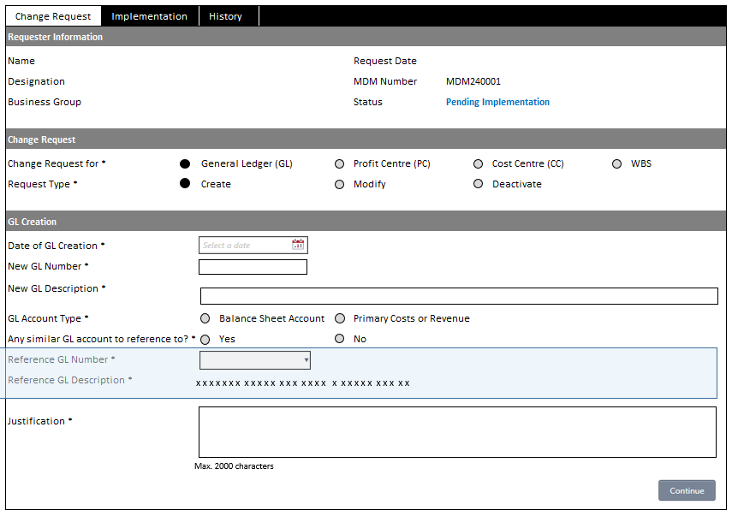

Figure 8 Screenshot of Implementation

* Once the BPO approves the form, it redirects to the implementer, and the status is marked as "Pending Implementation."
* In this form, which displays details on Creation/Modification/Deactivation submitted by the requester, all fields are presented in a non-editable format. The Implementer has view-only access.
* If the implementer is satisfied with the request, they can proceed to implement it by clicking on the "Continue" button.

**Implementation Tab:**

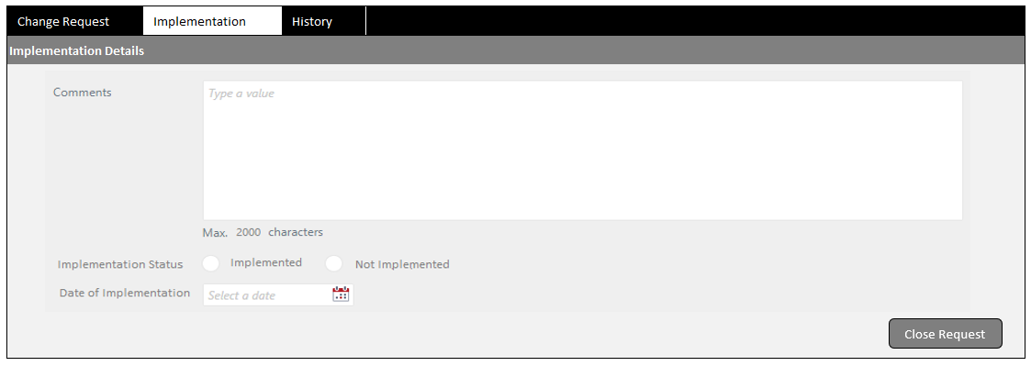

Figure 9 Screenshot of Implementation Tab

* The implementer can conclude the request by choosing the "Implementation" option in the Implementation status. It is mandatory to input the date of implementation, and comments are required.
* When the "Implementation Status" is set to "Implemented," and the implementer clicks on "Close Request," the relevant data will be updated in the Master Data list.

**History Tab:**

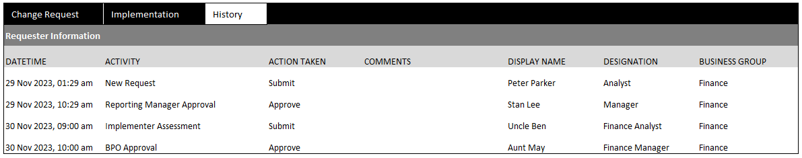

Figure 10 Screenshot of History Tab

# Appendix A: Data fields Description:

**New request GL Creations:**

| S.No | Data Field | Mandatory (Y/N) | Data Type | Options |
| --- | --- | --- | --- | --- |
|  | Change Request for | Yes | Radio button | General Ledger (GL); Profit Centre (PC); Cost Centre (CC); WBS |
|  | Request Type | Yes | Radio button | Create; Modify; Deactivate |
|  | Date of GL Creation | Yes | Date Picker | Date format: DD-MM-YYY |
|  | New GL Number | Yes | Free Text | Exact 6 Digits (To be confirmed - TBC) |
|  | New GL Description | Yes | Free Text | 100-character limit (TBC) |
|  | GL Account Type | Yes | Radio Button | Balance Sheet Account; Primary Costs or Revenue |
|  | Any similar GL Account to reference to? | Yes | Radio Button | Yes; No |
|  | a) If Yes to above question, |  |  | Show Reference GL section |
|  | Reference GL Number | Yes | Drop Down |  |
|  | Reference GL Description | NA | NA | Auto-populated based on the selected Reference GL Number |
|  | b) If No to above question, |  |  | Hide Reference GL section |
|  | Justification | Yes | Free text | 2,000-character limit |

**New request GL Modification**

| S.No | Data Field | Mandatory (Y/N) | Data Type | Options |
| --- | --- | --- | --- | --- |
|  | Change Request for | Y | Radio button | General Ledger (GL); Profit Centre (PC); Cost Centre (CC); WBS |
|  | Request Type | Y | Radio button | Create; Modify; Deactivate |
|  | Effective Date of GL Modification | Yes | Date Picker | DD-MM-YYYY |
|  | GL Number | Yes | Drop Down | Refer to the GL Listing tab. |
| Original section | | | | |
|  | GL Description |  | Text | Auto-populated based on the selected GL Number. The field is uneditable. |
|  | New section |  |  |  |
|  | GL Description | Yes | Text | Auto-populated based on the selected GL Number. The field is editable. |
|  | Any other requests | No | Free Text | 2,000 character limit |
|  | Justification | Yes | Free Text | 2,000 character limit |

**New request GL Deactivation:**

| S.No | Data Field | Mandatory (Yes/NA) | Data Type | Options |
| --- | --- | --- | --- | --- |
|  | Change Request for | Yes | Radio button | General Ledger (GL); Profit Centre (PC); Cost Centre (CC); WBS |
|  | Request Type | Yes | Radio button | Create; Modify; Deactivate |
|  | Effective Date of GL Modification | Yes | Date Picker | DD-MM-YYYY |
|  | GL Number | Yes | Drop Down | Refer to the GL Listing tab. |
|  | GL Description | NA | NA | Auto-populated based on the selected GL Number |
|  | Justification | Yes | Free Text | 2,000 character limit |

**New request CC Creations:**

|  |  |  |  |  |
| --- | --- | --- | --- | --- |
| S.No | Data Field | Mandatory (Yes/NA) | Data Type | Options |
|  | Change Request for | Yes | Radio button | General Ledger (GL); Profit Centre (PC); Cost Centre (CC); WBS |
|  | Request Type | Yes | Radio button | Create; Modify; Deactivate |
|  | Company Code | NA | NA, auto-populated | SL01 (Singapore LNG Corporation) |
|  | Effective Date of CC Creation | Yes | Date Picker | DD-MM-YYYY |
|  | Cost Centre Name | Yes | Free Text | 100-character limit (TBC) |
|  | Person Responsible | Yes | Person Picker |  |
|  | Justification Box | Yes | Free text | 2,000 character limit |
|  | Cost Centre Code | _ | _ | Input by Admin during Implementation will update the Cost Centre Code in the database. |
|  | Cost Centre Name | _ | _ | Input by Admin during Implementation will update the Cost Centre Name in the database. |

**New request CC Modification:**

| S.No | Data Field | Mandatory (Yes/NA) | Data Type | Options |
| --- | --- | --- | --- | --- |
|  | Change Request for | Yes | Radio button | General Ledger (GL); Profit Centre (PC); Cost Centre (CC); WBS |
|  | Request Type | Yes | Radio button | Create; Modify; Deactivate |
|  | Company Code | NA | NA, auto-populated | SL01 (Singapore LNG Corporation) |
|  | Effective Date of CC Modification | Yes | Date Picker | DD-MM-YYYY |
|  | Cost Centre Code | Yes | Drop Down |  |
| Original section | | | | |
|  | Person Responsible |  |  | Auto-populated based on the selected Cost Centre. The field is uneditable. |
|  | Cost Centre Name |  |  | Auto-populated based on the selected Cost Centre. The field is uneditable. |
| New section | | | | |
|  | Person Responsible | Yes | Person Picker | Auto-populated based on the selected Cost Centre. The field is editable. |
|  | Cost Centre Name | Yes | Free Text | Auto-populated based on the selected Cost Centre. The field is editable. |
|  | Justification Box | Yes | Free text | 2,000 character limit |

**New request CC Deactivation:**

| S.No | Data Field | Mandatory (Yes/NA) | Data Type | Options |
| --- | --- | --- | --- | --- |
|  | Change Request for | Yes | Radio button | General Ledger (GL); Profit Centre (PC); Cost Centre (CC); WBS |
|  | Request Type | Yes | Radio button | Create; Modify; Deactivate |
|  | Company Code | NA | NA, auto-populated | SL01 (Singapore LNG Corporation) |
|  | Effective Date of Deactivation | Yes | Date Picker | DD-MM-YYYY |
|  | Cost Centre Code | Yes | Drop Down | The cost center name also appears |
|  | Cost Centre Name | NA | NA | Auto-populated based on the selected Cost Centre. The field is uneditable. |
|  | Justification Box | Yes | Free text | 2,000 character limit |

**New Request PC Creation:**

|  |  |  |  |  |
| --- | --- | --- | --- | --- |
| S.No | Data Field | Mandatory (Yes/NA) | Data Type | Options |
|  | Change Request for | Yes | Radio button | General Ledger (GL); Profit Centre (PC); Cost Centre (CC); WBS |
|  | Request Type | Yes | Radio button | Create; Modify; Deactivate |
|  | Effective Date of PC Creation | Yes | Date Picker | DD-MM-YYYY |
|  | Profit Centre Name | Yes | Free text | 100-character limit (TBC) |
|  | Person Responsible | Yes | Person Picker |  |
|  | Justification | Yes | Free text | 2,000 character limit |
|  | Profit Centre Code |  |  | Input by Admin during Implementation, will update the Profit Centre Code in the database. |
|  | Profit Centre Name |  |  | Input by Admin during Implementation, will update the Profit Centre Name in the database. |

**New Request PC Modification:**

| S.No | Data Field | Mandatory (Yes/NA) | Data Type | Options |
| --- | --- | --- | --- | --- |
|  | Change Request for | Yes | Radio button | General Ledger (GL); Profit Centre (PC); Cost Centre (CC); WBS |
|  | Request Type | Yes | Radio button | Create; Modify; Deactivate |
|  | Effective Date of PC Modification | Yes | Date Picker | DD-MM-YYYY |
|  | Profit Centre Code | Yes | Drop Down | Refer to the PC Listing tab. |
| Original section | | | | |
|  | Profit Centre Name |  |  | Auto-populated based on the selected Profit Centre. The field is uneditable. |
|  | Person Responsible |  |  | Auto-populated based on the selected Profit Centre. The field is uneditable. |
| New section | | | | |
|  | Profit Centre Name | Yes | Text | Auto-populated based on the selected Profit Centre. The field is editable. |
|  | Person Responsible | Yes | Person Picker | Auto-populated based on the selected Profit Centre. The field is editable. |
|  | Justification | Yes | Free text | 2,000 character limit |

**New Request PC Deactivation:**

|  |  |  |  |  |
| --- | --- | --- | --- | --- |
| S.No | Data Field | Mandatory (Yes/NA) | Data Type | Options |
|  | Change Request for | Yes | Radio button | General Ledger (GL); Profit Centre (PC); Cost Centre (CC); WBS |
|  | Request Type | Yes | Radio button | Create; Modify; Deactivate |
|  | Effective Date of Deactivation | Yes | Date Picker | DD-MM-YYYY |
|  | Profit Centre Code | Yes | Drop Down | Refer to the PC Listing tab |
|  | Profit Centre Name | NA | NA | Auto-populated based on the selected Profit Centre. The field is uneditable. |
|  | Justification | Yes | Free text | 2,000 character limit |

**New Request WBS creation:**

| S.No | Data Field | Mandatory (Yes/NA) | Data Type | Options |
| --- | --- | --- | --- | --- |
|  | Change Request for | Yes | Radio button | General Ledger (GL); Profit Centre (PC); Cost Centre (CC); WBS |
|  | Request Type | Yes | Radio button | Create; Modify; Deactivate |
|  | Effective Date of WBS Creation | Yes | Date Picker | DD-MM-YYYY |
|  | Project Type | Yes | Radio button | Opex (value = OX); Capex (value = CX) |
|  | Nature of Cost / Expenses to incur | Yes | Free text | 2,000 character limit Description of scope of work required. <Examples> |
|  | Cost Centre Code | Yes | Drop Down | Ref CC Listing |
|  | WBS Description | Yes | Free text | 40 character limit (TBC) |
|  | Was this item budgeted for? | Yes | Radio Button | Yes; No |
|  | If yes, pls provide the GL Number and Item Description |  | Free text | 100 character limit (TBC) |
|  | If no, pls provide justification | Yes | Free text | 2,000 character limit |
|  | WBS Element |  |  | Input by Admin during Implementation, this will update the WBS Element in the database. |
|  | WBS Description |  |  | Input by Admin during Implementation, this will update the WBS Description in the database. |

**New Request WBS Modification:**

| S.No | Data Field | Mandatory (Yes/NA) | Data Type | Options |
| --- | --- | --- | --- | --- |
|  | Change Request for | Yes | Radio button | General Ledger (GL); Profit Centre (PC); Cost Centre (CC); WBS |
|  | Request Type | Yes | Radio button | Create; Modify; Deactivate |
|  | Effective Date of WBS Modification | Yes | Date Picker | DD-MM-YYYY |
|  | WBS Element | Yes | Drop Down |  |
| Original section | | | | |
|  | WBS Description |  |  | Auto-populated based on the selected WBS Element. Field is uneditable. |
| New section | | | | |
|  | WBS Description | Yes | Text | 40 character limit (TBC) Auto-populated based on the selected WBS Element. Field is editable. |
|  | Justification | Yes | Free text | 2,000 character limit |

**New Request WBS Deactivation:**

|  |  |  |  |  |
| --- | --- | --- | --- | --- |
| S.No | Data Field | Mandatory (Yes/NA) | Data Type | Options |
|  | Change Request for | Yes | Radio button | General Ledger (GL); Profit Centre (PC); Cost Centre (CC); WBS |
|  | Request Type | Yes | Radio button | Create; Modify; Deactivate |
|  | Effective Date of WBS Deactivation | Yes | Date Picker | DD-MM-YYYY |
|  | WBS Element | Yes | Drop Down | Refer to WBS Listing |
|  | WBS Description | NA | NA | Auto-populated based on the selected WBS Element |
|  | Justification | Yes | Free text | 2,000 character limit |

# Environments

The below table describes the various environments.

|  |  |
| --- | --- |
| **Environment Name** | **Purpose** |
| DEV | This environment will be used for Development. |
| UAT | This environment will be used for User Acceptance Testing |
| MONITORING & MANAGEMENT | This environment will be used for platform monitoring & management process. |

|  |
| --- |
| Contact us |
| Deven Chhaya  Infrastructure Advisory  T +65 8163 4921  **E** devenchhaya@kpmg.com.sg |
|  |
|  |
| Abhishek Dubey  Infrastructure Advisory  T +65 9783 4584  **E** abhishekdubey3@kpmg.com.sg  Some or all of the services described herein may not be permissible for KPMG audit clients and their affiliates or related entities.  Some or all of the services described herein may not be permissible for KPMG audit clients and their affiliates or related entities.  Some or all of the services described herein may not be permissible for KPMG audit clients and their affiliates or related entities.  www.kpmg.com |
|  |
|  |
| © 2023 KPMG Services Pte. Ltd. (Registration No: 200003956G), a Singapore-incorporated company and a member firm of the KPMG global organization of independent member firms affiliated with KPMG International Limited, a private English company limited by guarantee. All rights reserved.  The information contained herein is of a general nature and is not intended to address the circumstances of any particular individual or entity. Although we endeavour to provide accurate and timely information, there can be no guarantee that such information is accurate as of the date it is received or that it will continue to be accurate in the future. No one should act on such information without appropriate professional advice after a thorough examination of the particular situation.  The KPMG name and logo are trademarks used under license by the independent member firms of the KPMG global organization. |